Batch: A3 Roll. No.: 16010122074
Experiment:
Grade: AA / AB / BB / BC / CC / CD /DD

Title: Using virtual labs to understand the data structures

Objective: Use of virtual labs to understand the concepts and theory with examples and verify the same with practice questions.

Expected Outcome of Experiment:

CO | Outcome
CO1 | Explain the different data structures used in problem solving
CO2 | Apply linear and non-linear data structure in application development
CO3 | Demonstrate sorting and searching methods.

Websites/books referred:
1. Reema Thareja: Data Structures
2. GeeksforGeeks.com
3. TutorialsPoint.com
Abstract: the virtual lab experiments help in understanding how various data structures work. They also emphasize on some important applications of various data structures and enable students to get familiarized with how certain applications can benefit from the choice of data structures.
Assigned data structure: (Teacher would assign one of the following to one student)
- Stack - https://ds1-iiith.vlabs.ac.in/exp/stacks-queues/stacks/stackdemo.html
- Infix and postfix - https://ds1-iiith.vlabs.ac.in/exp/infix-postfix/evaluation-of-postfix-expressions/postfix_eval.html
- Queue - https://ds1-iiith.vlabs.ac.in/exp/stacks-queues/stacks/stackdemo.html
- Bubble sort - https://ds1-iiith.vlabs.ac.in/exp/bubble-sort/bubble-sort/bsexercise.html
- Graph DFS - https://ds1-iiith.vlabs.ac.in/exp/depth-first-search/index.html
- Graph BFS - https://ds1-iiith.vlabs.ac.in/exp/breadth-first-search/index.html
- Binary search tree - https://ds1-iiith.vlabs.ac.in/exp/binary-search-trees/bst-insert/bstInsert.html
- Hash tables - https://ds1-iiith.vlabs.ac.in/exp/hash-tables/quadratic-probing/qp_practice.html
- Linked list - https://ds1-iiith.vlabs.ac.in/exp/linked-list/singly-linked-list/sllpractice.html

Aim / learning objective of the assigned expt:
To understand various operations performed on a singly linked list.

Concept and algorithm of the application/activity followed:
SINGLY LINKED LIST CONCEPT:
A singly linked list is a fundamental data structure in computer science used for organizing and managing a collection of elements, often referred to as "nodes." In a singly linked list:
- Elements (Nodes): Each element, or node, contains two parts: the data it stores and a reference (pointer) to the next node in the sequence. The data can be any type, such as integers, strings, or custom structures.
- Structure: The nodes are linked in a linear fashion, with each node pointing to the next node in the sequence, forming a chain. The first node is called the "head," and the last node typically has a reference to NULL, indicating the end of the list.
- Traversal: To access or traverse the elements of a singly linked list, you start at the head and follow the references to subsequent nodes until you reach the desired node. This makes forward traversal efficient, but reverse traversal is not as straightforward without extra references (in contrast to doubly linked lists).
- Dynamic Size: Singly linked lists can dynamically change in size by adding or removing nodes. This dynamic size feature makes them useful for situations where the size of the data structure may change over time.
- Insertions and Deletions: Inserting a node at the beginning or end of a singly linked list is typically a constant-time (O(1)) operation, assuming you have references to the relevant nodes. Inserting or deleting a node at an arbitrary position is an O(n) operation because you may need to traverse the list to reach the desired position.
- Memory Efficiency: Singly linked lists are memory-efficient for data elements that can be of variable size. However, they incur some memory overhead due to the storage of references in each node.
- Applications: Singly linked lists are used in various data structures, such as stacks, queues, symbol tables, and as the building blocks for more complex data structures like hash tables

- ALGORITHM FOR TRAVERSING A LINKED LIST
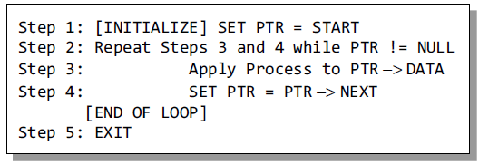
- ALGORITHM TO PRINT THE NUMBER OF NODES IN A LINKED LIST
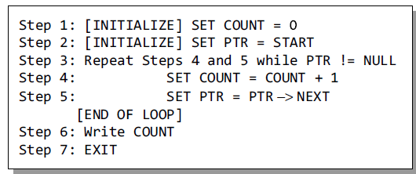

- ALGORITHM TO SEARCH A LINKED LIST
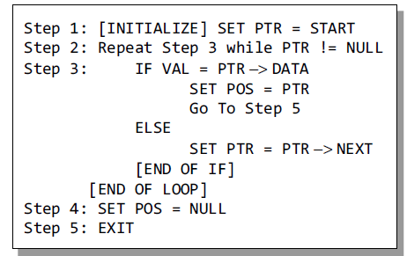

- ALGORITHM TO INSERT A NEW NODE AT BEGINNING
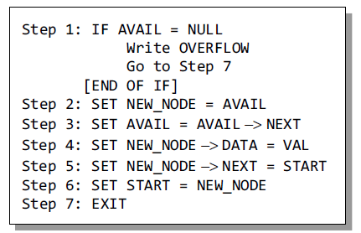
- ALGORITHM TO INSERT NEW NODE AT END
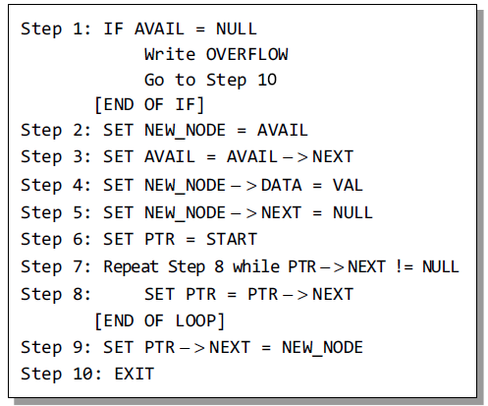

- ALGORITHM TO INSERT A NEW NODE AFTER A SPECIFIC NODE
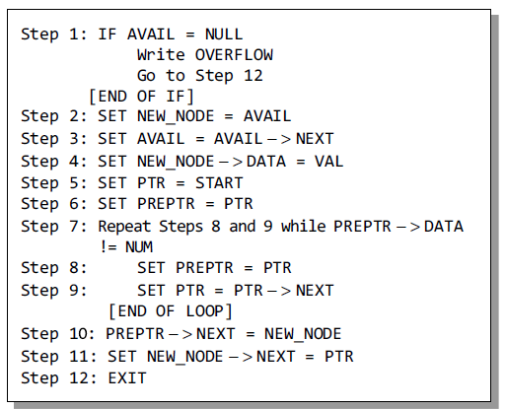

- ALGORITHM TO DELETE FIRST NODE
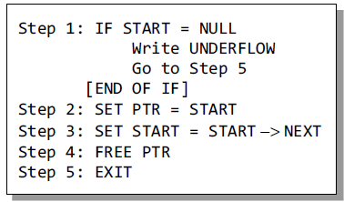

- ALGORITHM TO DELETE LAST NODE
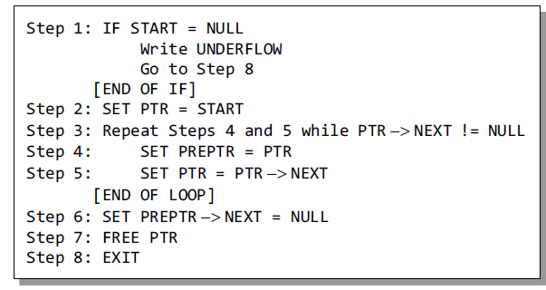
- ALGORITHM TO DELETE A NODE AFTER A GIVEN NODE
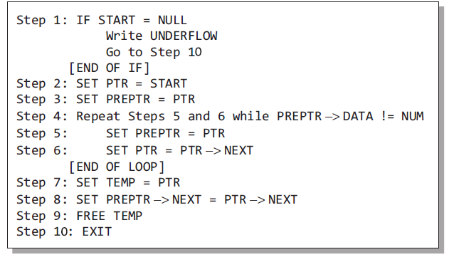

Demo execution screenshots:
- INSERT AT HEAD
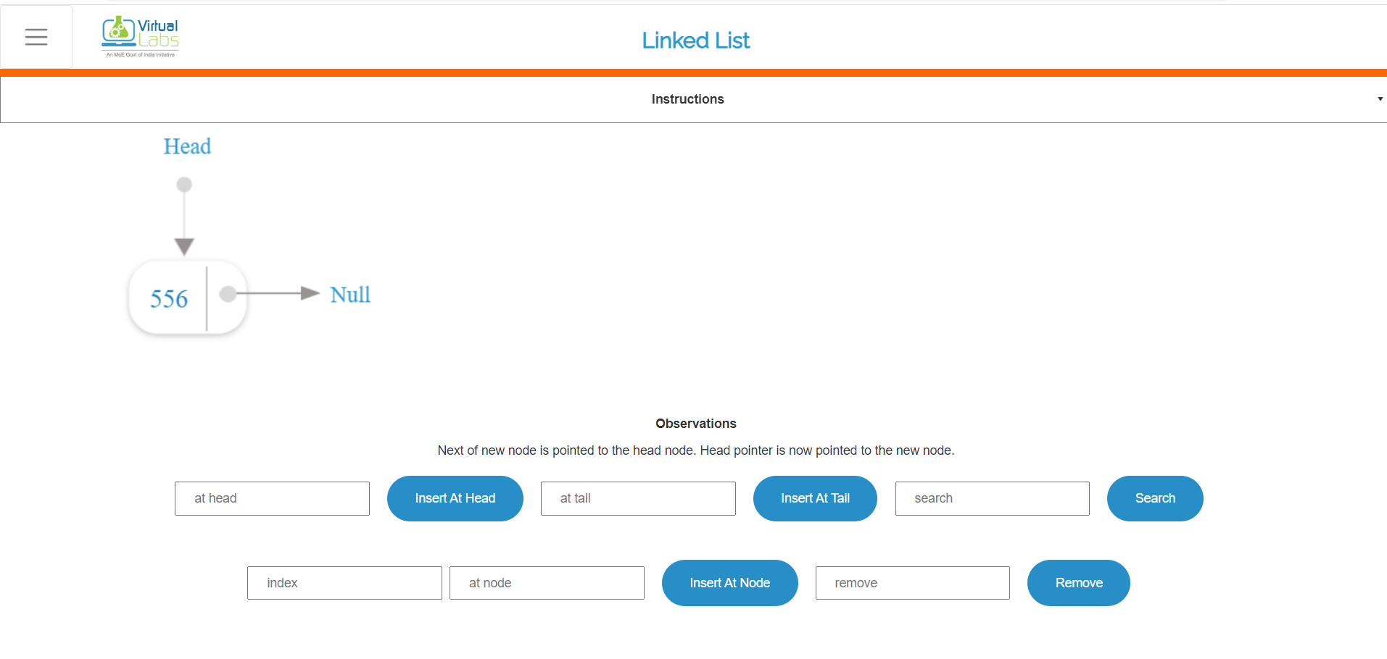
- INSERT AT TAIL
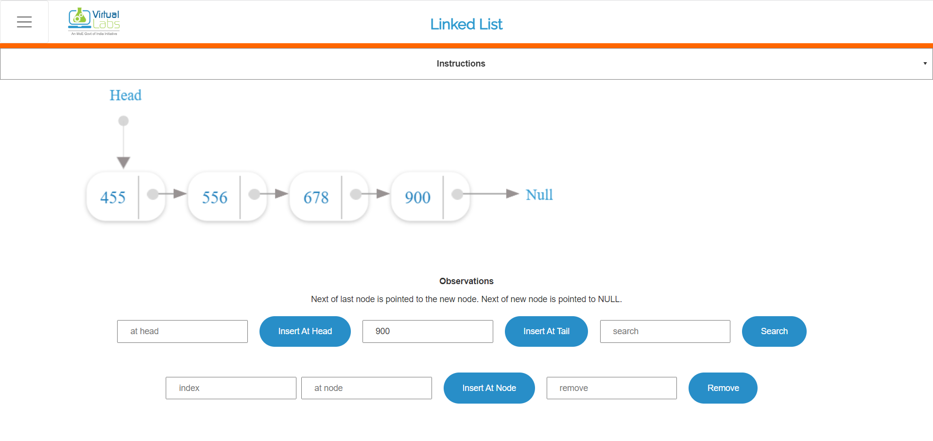

- SEARCHING
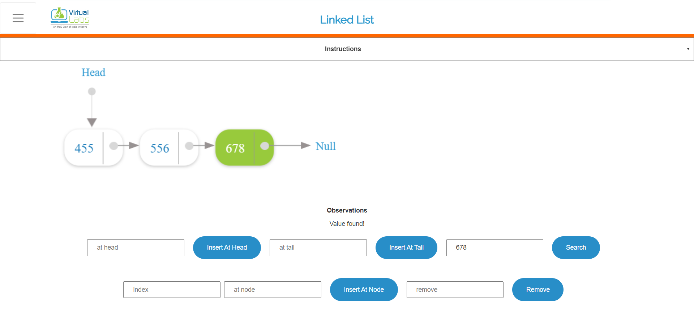

- INSERT AT SPECIFIED NODE
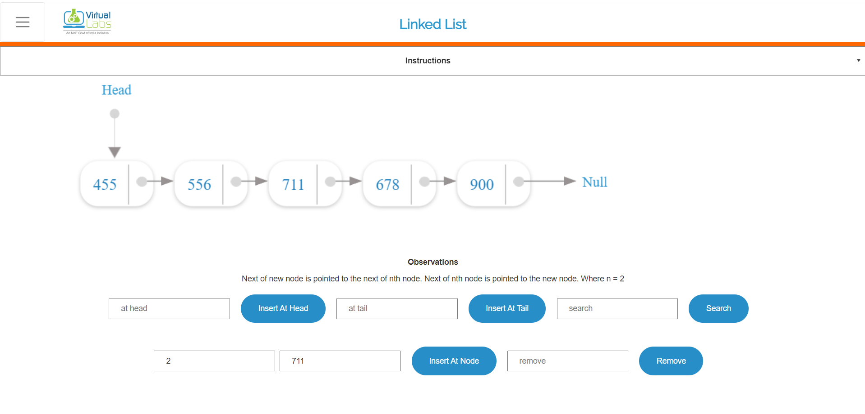

- REMOVE 556
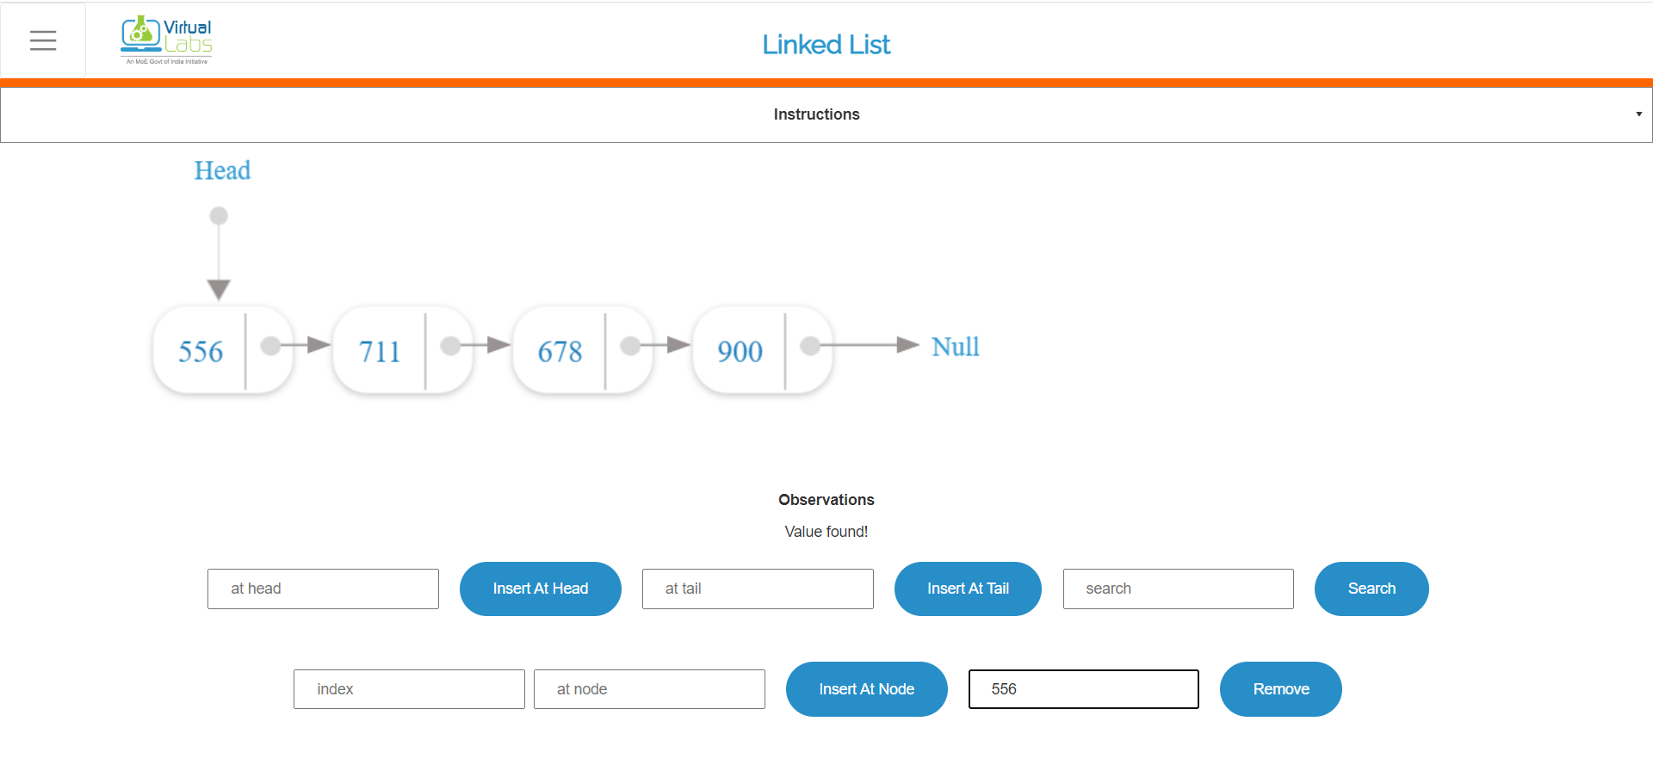

- AFTER REMOVING 556
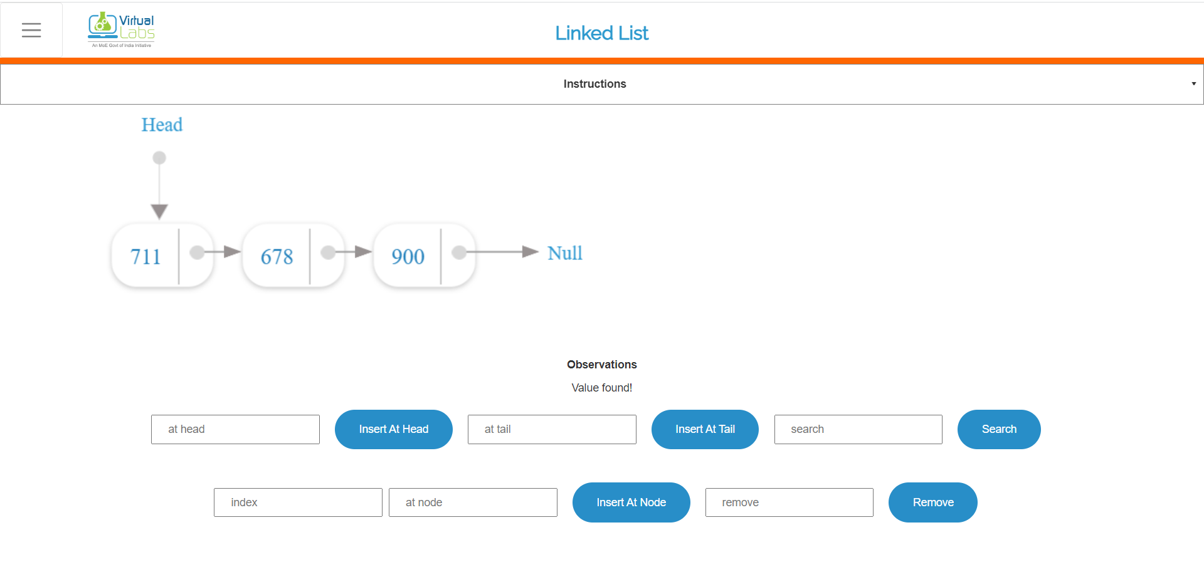

Practice problem screenshots:
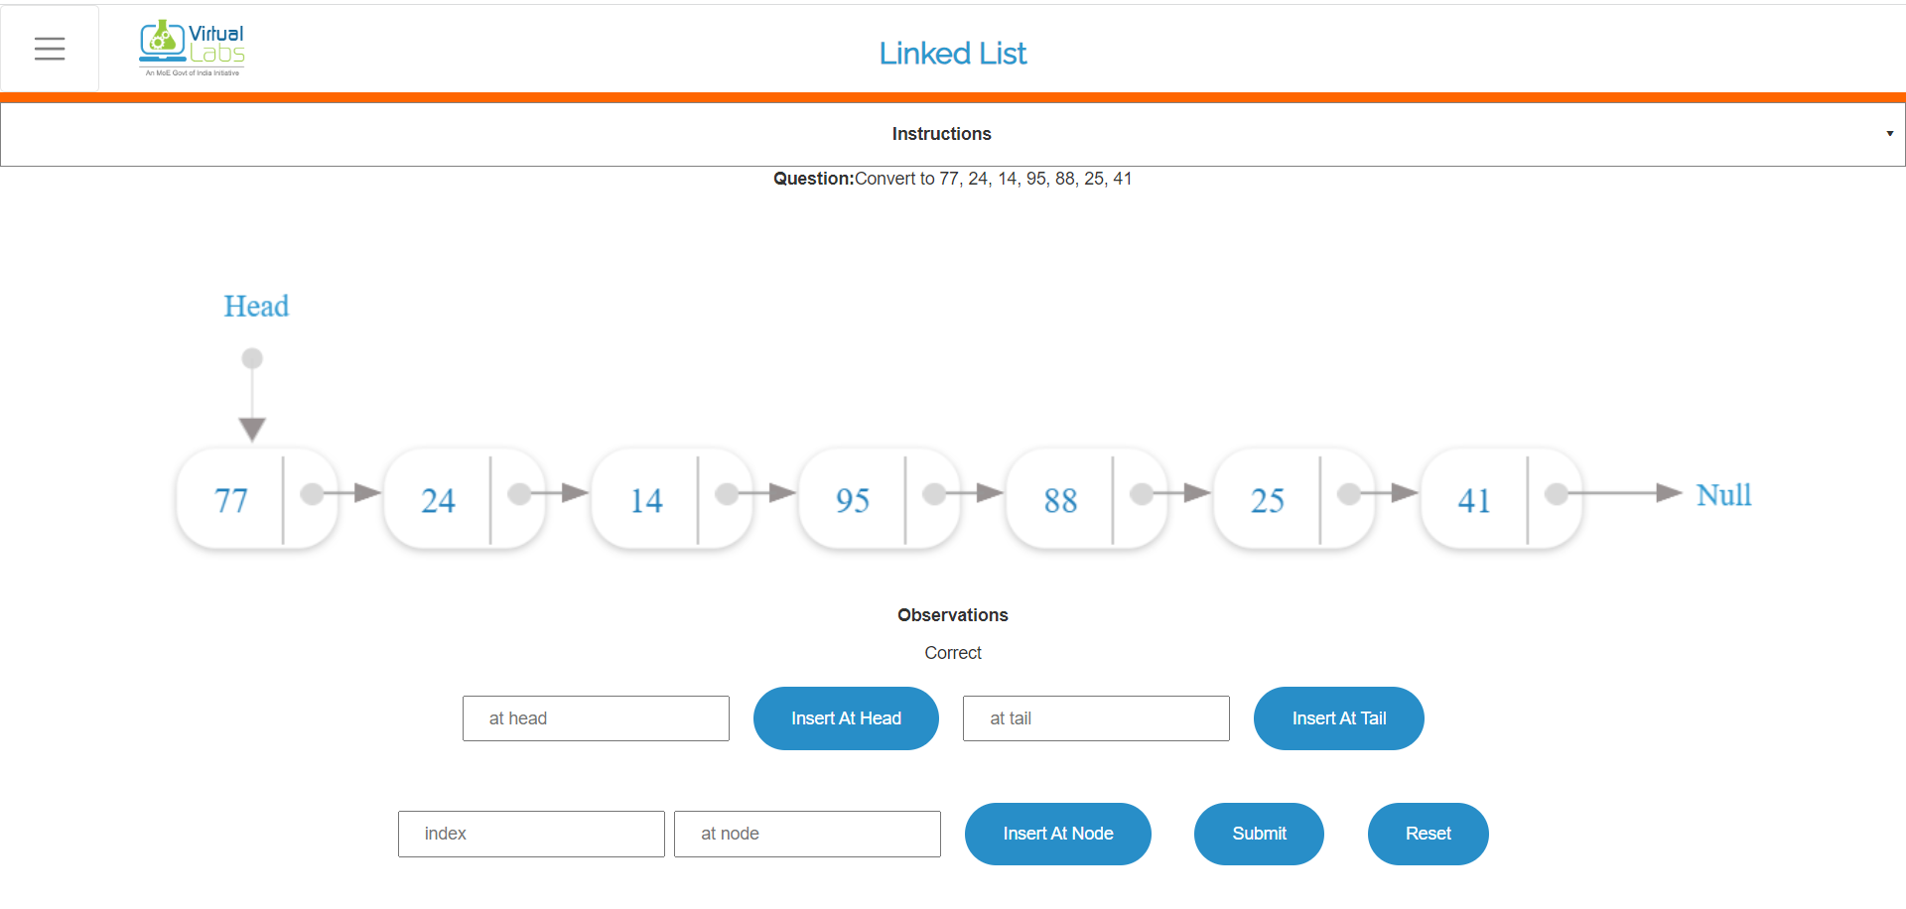

Quiz screenshots:
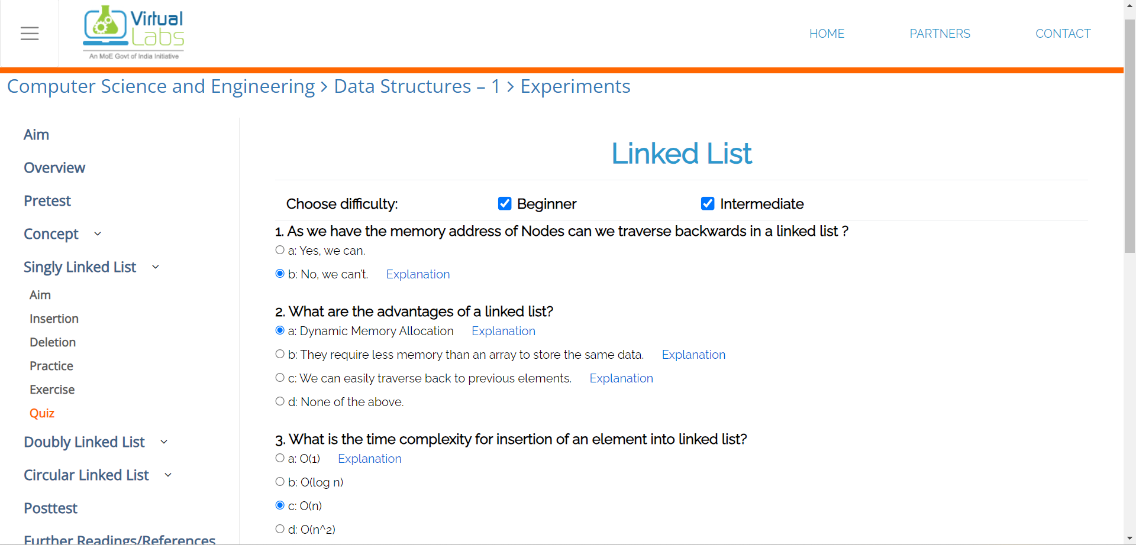

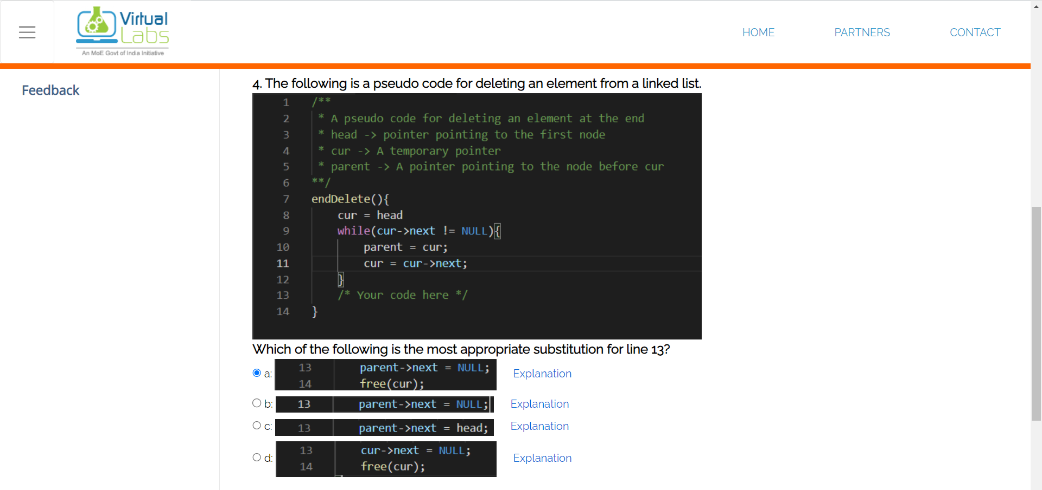

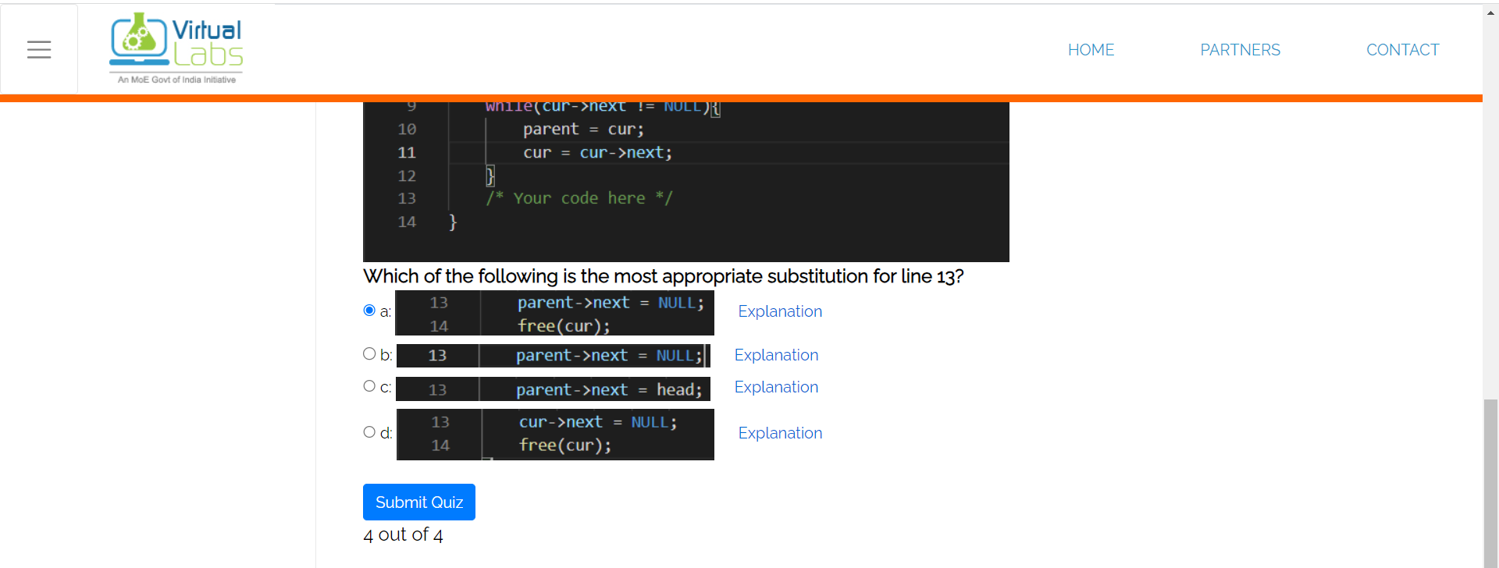

Conclusion and your take away after performing the virtual lab experiment: -

Hence, I learnt how to perform different operations on a singly linked list successfully. The visual animations and the representation of the linked list on the virtual lab website helped me to understand how a linked list actually works.

